Screenshots

Librarian Section:

1. Librarian Login Page

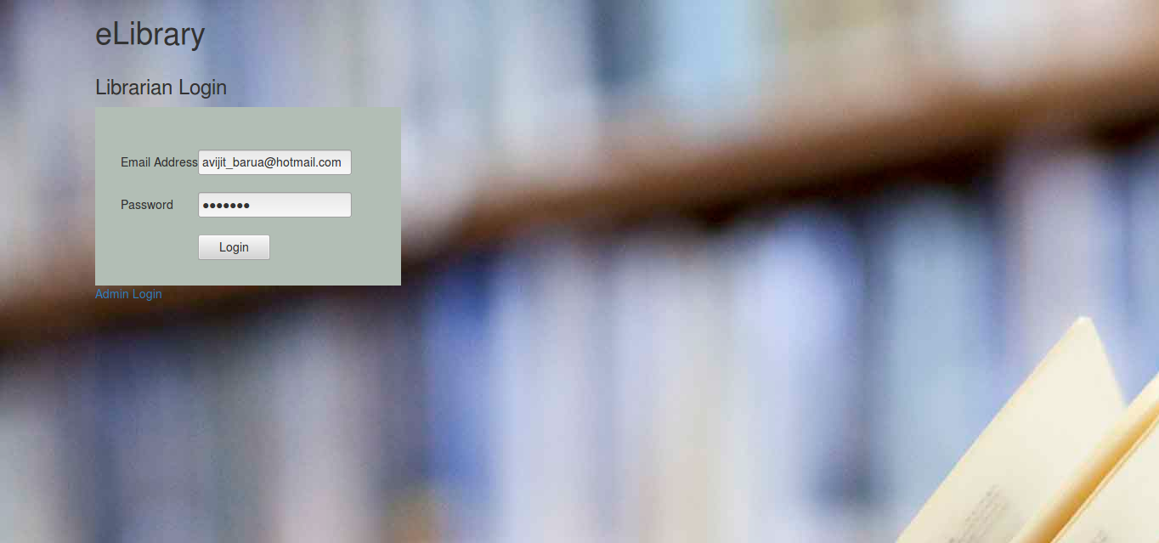

email : [mowdud@hotmail.com](mailto:mowdud@hotmail.com)

Pass : mowdud1234

If email and password are wrong this error message will be shown.

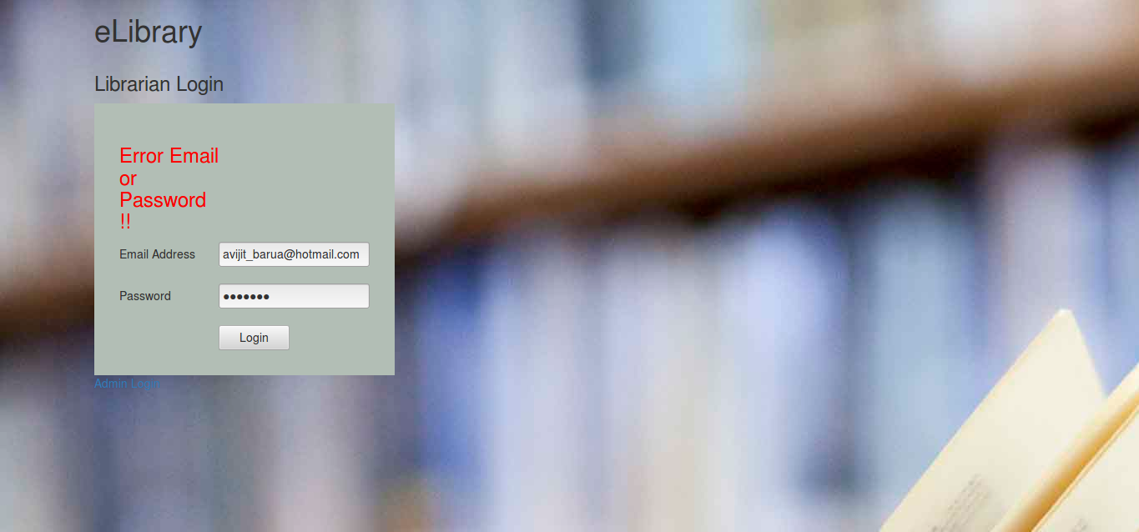

2.Home Page



3.Now click on Add Book section

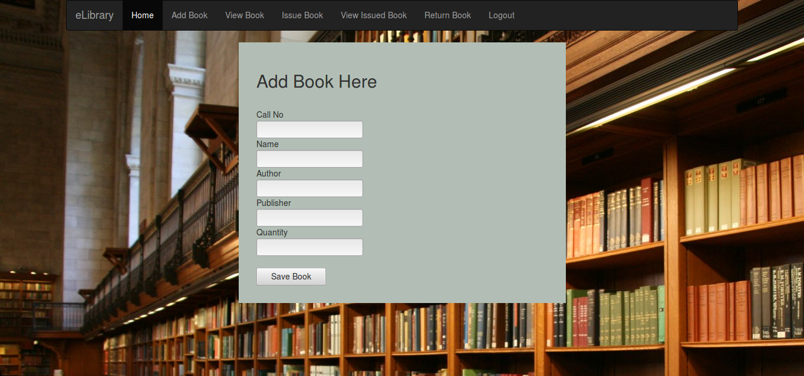

After filling all field hit Save Book button. A successful message will be appeared.

You cannot keep any field empty while saving book !

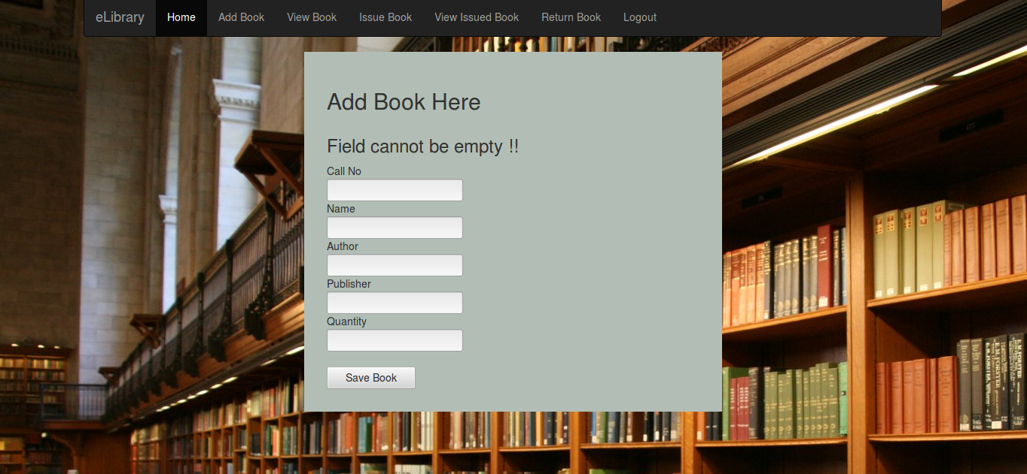

4. Now click on View Book section

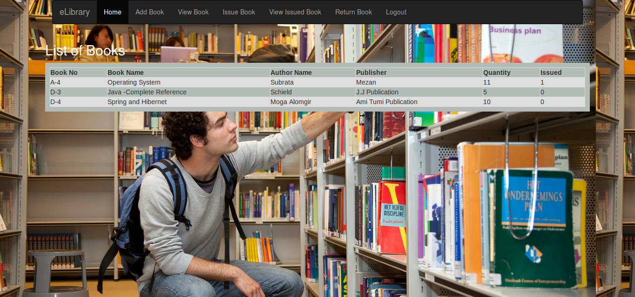

5. Click on Issue Book

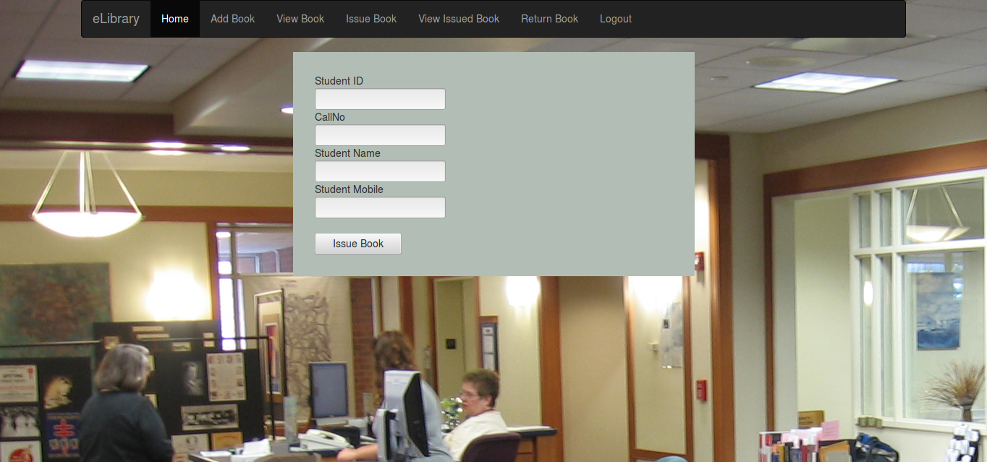

Fill all the field and hit Issue Book button !

6.Now click on View Issued Book

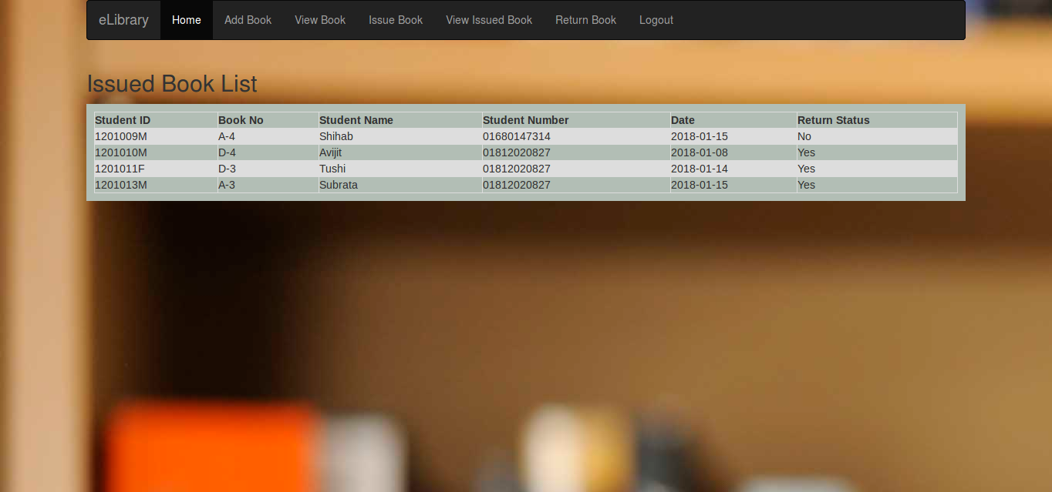

All books issued to the students will be shown with return status .

7.Click Return Book section

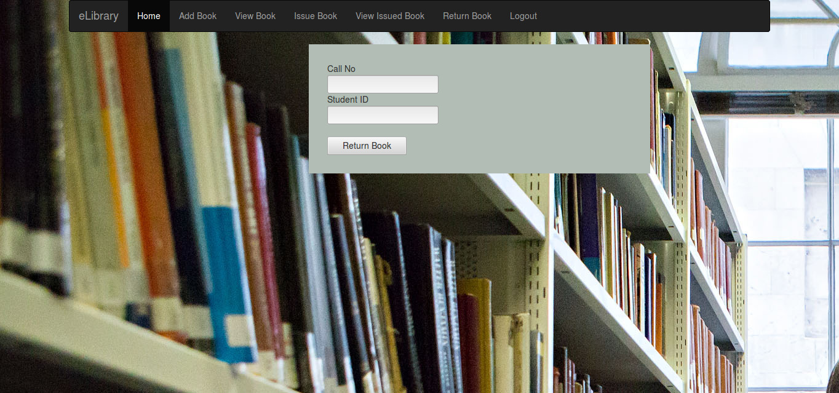

Filling fields and hitting Return Book button return status of student will be “Yes” in View Issued Book section!

Clicking Logout you will directed to the login page.

Admin Section:

1. Admin login page

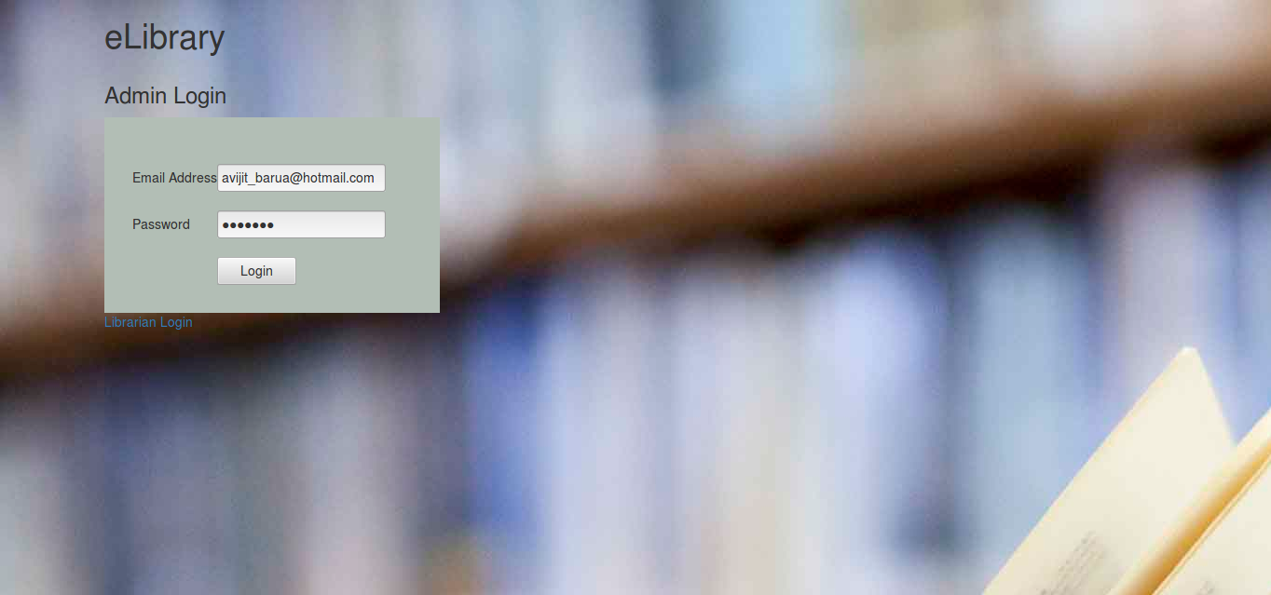

email :[avijit_barua@hotmail.com](mailto:avijit_barua@hotmail.com)

Pass : avi1234

2. Home Page



3. Click Add Librarian

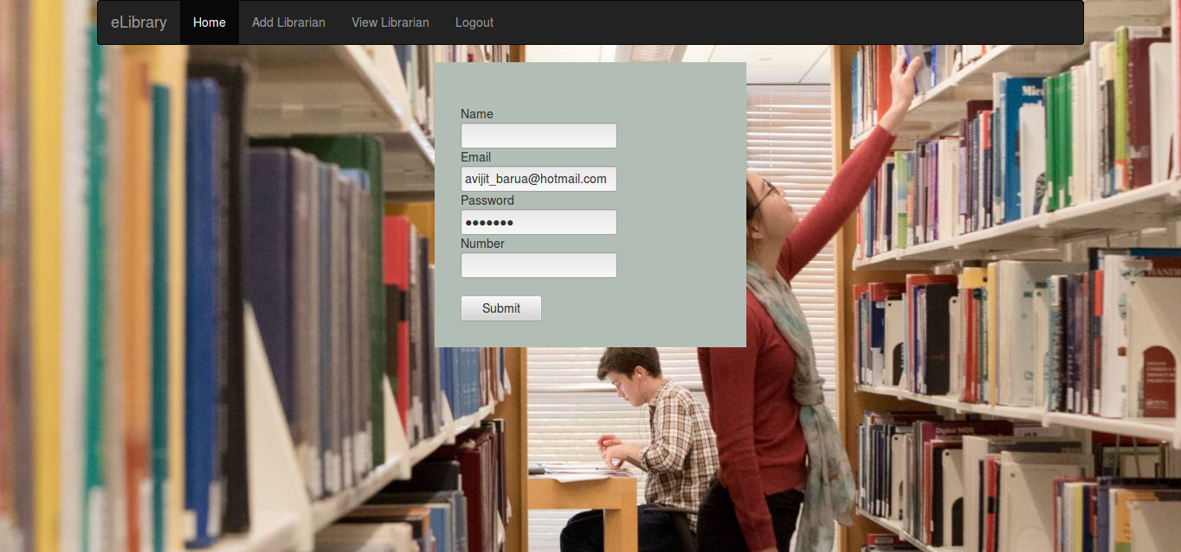

4. Click View Librarian

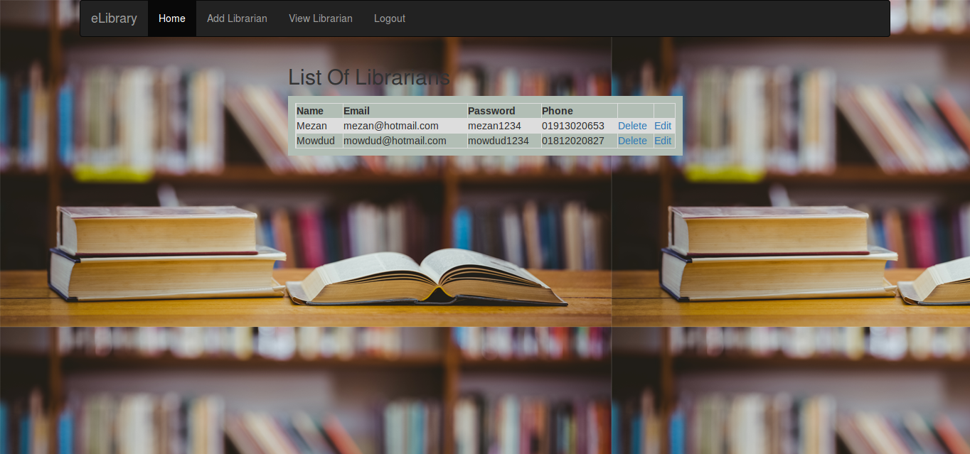

5. Clicking Edit link this page will be appeared .

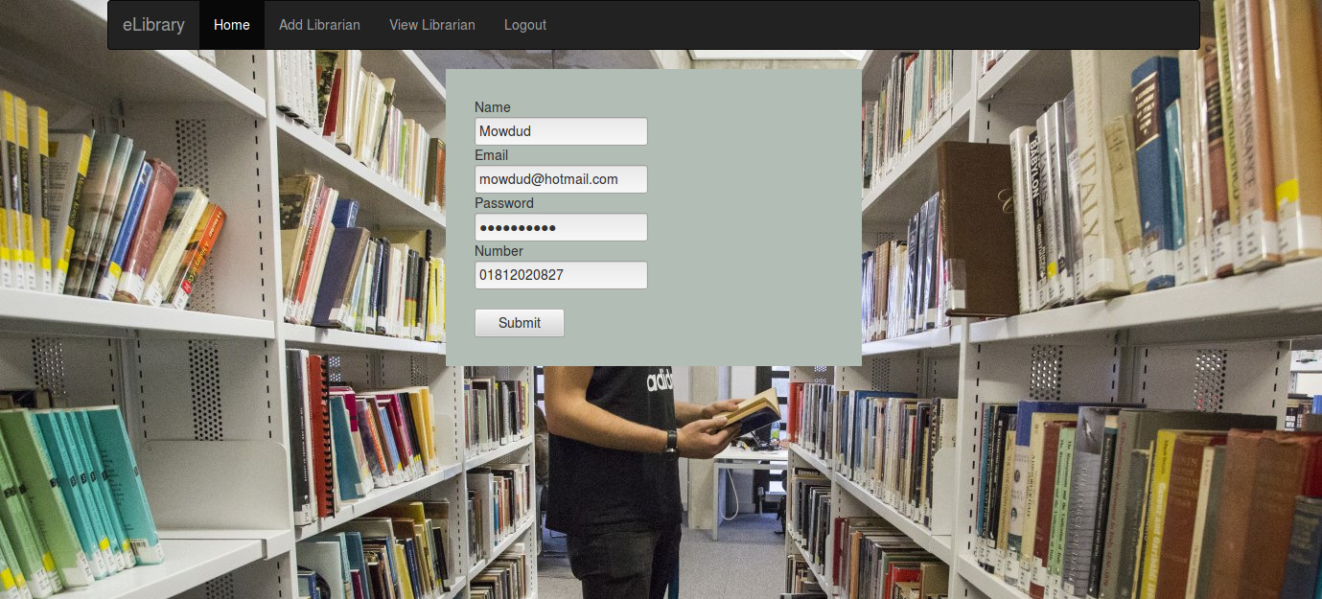

Editing fields click submit.

6. Clicking Delete librarian will be deleted !